Rules:

Use your creative side and have fun

No larger than 24 inches on any side

Must use the theme title in the name of the quilt.

Ex. **As the Elephant dances in the Night**, the wolf howled at the moon.

The entry must be a standard quilt with three layers, and quilted – creative finishing is allowed.

Only one entry per person.  Use the regular quilt entry form for your challenge quilt.

HAVE FUN!

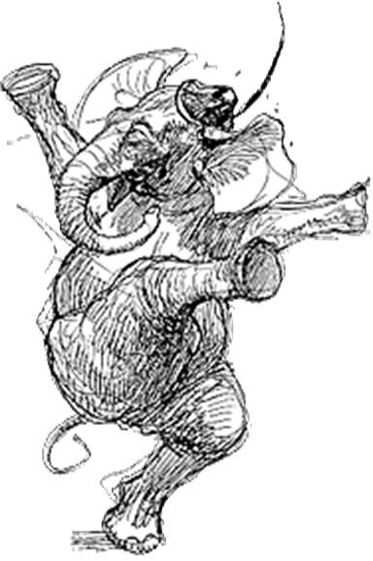

**As the Elephant**

**Dances**

**in the**

**Night**